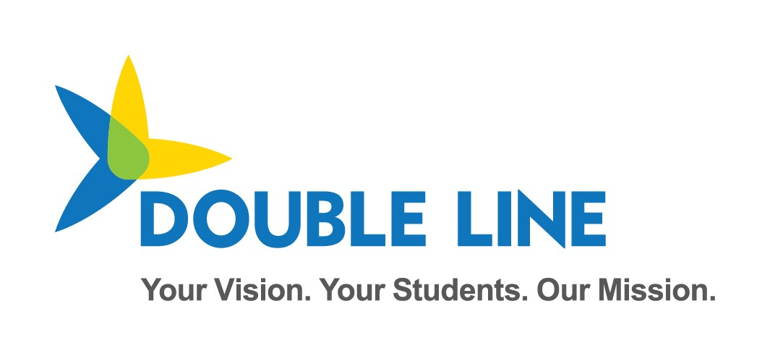

Ed-Fi ODS API Overview for SIS Vendor and District

School Year 2022-2023

Minnesota Department of Education & Minnesota IT Services

Automated Student Data Collection System

Revision date: 3/14/2022

Contents

Change Log 4

Overview 1

MN Sandbox Certification Testing 1

Test Sandbox Environment URLs 1

Sandbox Admin Website 1

Swagger UI 2

Sandbox Base and OAuth URLs 2

ODS/API oauth URL 3

Sandbox Environment Helpful Tips 3

Identifiers: Schools vs. Buildings 5

2022-2023 Data Requirements and API Resources 5

API Documentation 5

Example 5

Mapping Documentation 6

Education Organization Id usage by Resource 6

API Resources and Certification Scenarios 7

Read-Only API endpoints 8

Resource: LocalEducationAgencies 8

Resource: Schools 8

Resource: Post-Secondary Institutions 8

Resource: Course (State Level Only) 8

Resource: Staff 9

Resource: Program 9

Ed-Fi Model Dependency Graphs 2

MARSS collection 2

MCCC collection 3

Early Education Enrollment and Parent collection 4

Staging Environment Load and Quality Check 4

Ed-Fi / MARSS Identities API Integration Test 4

Create Student ID Test 1 5

Create Student ID Test 2 5

Ed-Fi / MARSS Student Record Validation Test 6

Student Validation Process Overview 6

Validate Student ID Test 1 6

Validate Student ID Test 2 7

# Change Log

|  |  |  |
| --- | --- | --- |
| **Version** | **Date** | **Description of Changes** |
| v1.0 | 02/01/2022 | Initial Version for SY22-23 Collection |
| V1.01 | 03/07/2022 | Minor formatting and review; no significant changes. |
| V1.02 | 03/15/2022 | Additional minor changes, addition of Early Ed dependency graph |

# Overview

Student Information Systems vendors integrating with the Minnesota Department of Education's (MDE) Ed-Fi Automated Student Data Collection system are required to pass 2 levels of testing prior to being granted a district's API key and secret to the production environment.

First, vendors are required to demonstrate their ability to submit specific API resources and elements encompassed within the various MDE Data collection requirements. This first phase is executed in the MNIT Ed-Fi Test Sandbox environment.

Important notes about the Sandbox environment:

* The Test Sandbox environment does not include integration with the Identities API endpoint, meaning student identity is not validated on student records posted to a Sandbox.
* API profiles are not enforced in the Test Sandbox environment, however you may be required to demonstrate appropriate implementation of API profile use in your API transactions.

When all scenarios are verified in the Sandbox testing environment, the SIS vendor is granted access to the Staging Environment. Vendors must perform a test load of their district's real student demographic data in the Staging environment. During this test, Student IDs are validated against the Ed-Fi Identities Service to ensure valid ids are being inserted to the Ed-Fi ODS. MARSS comparison checks and additional data quality verifications are executed in the Staging Environment.

Once the Staging data reaches a satisfactory level of quality as determined by MDE, MNIT, and the District, MNIT will enable the vendor to obtain a key and secret for the production environment.

This document includes the Certification Requirements for both the scenario-based sandbox testing and staging environment data loading.

*Note: many URLs in this document will not be active at first, and thus marked with:*

Not currently active

*Please note that these URLs are also subject to change upon actual Ed-Fi implementation for the 2022-2023 school year.*

# MN Sandbox Certification Testing

When certification begins, vendors will be required to generate a key and secret to a sandbox ODS/API with no sample data pre-loaded. This ODS will contain the Minnesota Education School and District records synchronized with MDE-ORG, MN specific descriptors, District Programs, and the State Course Catalog and Staff records required for the MCCC data collection. When submitting data for each of the Certification scenarios, we ask that you use a district you have access to, and schools within that district.

## Test Sandbox Environment URLs

### Sandbox Admin Website

<https://test.edfi5.education.mn.gov/admin/>

As part of Sandbox certification, you will need access to the [Sandbox Admin Site](https://test.edfi5.education.mn.gov/admin/). To request an account, [contact MDE by email](mailto:EdFiProjectSupportMNIT.MDE@state.mn.us). In the Sandbox Admin Site, you will be able to create ODS instances to use for development and testing of your integrations. ([The Ed-Fi TechDocs](https://techdocs.ed-fi.org/display/ODSAPI31/Using+the+Sandbox+Administration+Portal) have more detailed instructions on setting up sandboxes.)

### Swagger UI

<https://test.edfi5.education.mn.gov/swagger/>

We continue to use the [Swagger UI tool](https://swagger.io/tools/swagger-ui/) to visualize and interact with the ODS API. Developers can access this [UI for MDE's Sandbox](https://test.edfi5.education.mn.gov/swagger/) to test-drive Create, Read, Update, and Delete (CRUD) actions before building integrations as necessary.

*Please note:* MDE’s Swagger website has been customized to remove the generic Resources section. All MN Specific resources can be found under the Profiles for each School Year:

* Minnesota-Twenty-**One**-Twenty-**Two**-SISVendor-Profile – For Data submitted to the School Year 2021-**2022** ODS
* Minnesota-Twenty-**Two**-Twenty-**Three**-SISVendor-Profile – For Data submitted to the School Year 2022-**2023** ODS

*Note: The Identities Section is provided as documentation only – and is not functional in the Sandbox environment*

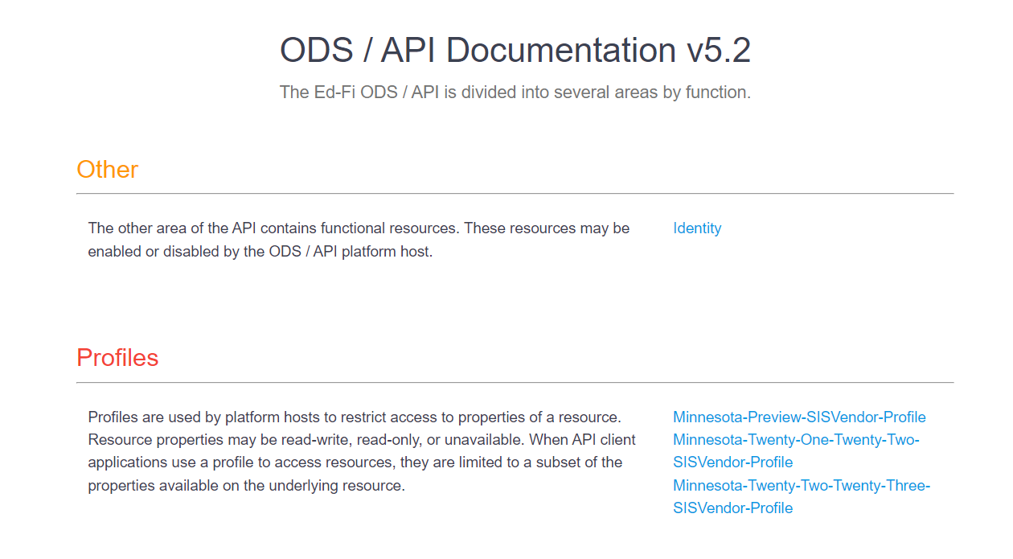

### Sandbox Base and OAuth URLs

Developers can further test their code integrations at the URLs in this section.

* The base URL for the ODS/API is: https://test.edfi5.education.mn.gov/api/
* The Data Management URL is: https://test.edfi5.education.mn.gov/api/data/v3

Please note details below on how the URL changes for addressing extension vs core resources.

#### Extensions

The URL for addressing MN extension resources should include ‘mn’ after v3. For example, when addressing studentSection504PlanProgramAssociations, a Minnesota Dept of Education extension entity, the URL is:

…/api/data/v3/**MN**/studentSection504PlanProgramAssociations

#### Core

The URL for addressing core resources should include ‘ed-fi’ after v3. For example, when addressing StudentSchoolAssociation, a core ed-fi entity, the URL is:

…/api/data/v3/**ed-fi**/StudentSchoolAssociation

**Important Note**: the school year must be included after “/v3/” and before the core/extension namespace in QA, Stage and Production, **but not in Sandbox.**

For example:

…/api/data/v3/**2023**/ed-fi/StudentSchoolAssociation

…/api/data/v3/**2023**/MN/studentSection504PlanProgramAssociations

### ODS/API oauth URL

[https://test.edfi5.education.mn.gov/api/oauth](https://test.edfi5.education.mn.gov/api/oauth/token)

Authentication in Ed-Fi Suite 3 ODS/API uses two-legged OAuth 2.0 Client Credentials Grant Flow. More information and sample API calls are located in [the Ed-Fi tech docs.](https://techdocs.ed-fi.org/display/ODSAPIS3V520/Authorization)

## Sandbox Environment Helpful Tips

* In the staging and production environments, SIS vendor API keys will be associated with a claim set limiting access to only the API resources included in this document. This claim set has been enabled in the Sandbox environment. When you access a resource not included in the claim set, you will receive the following message in the response "Access to the resource could not be authorized. Are you missing a claim?”
* A SIS Vendor profile has been created limiting access to specific properties on each of the resources required in each School Year. Profiles are tied to your key and secret and auto-enabled in Staging and Production – meaning you will not have to include the profile in the “accept” or “content-type” headers of the request for the profile to take effect.
* When creating a sandbox, you have the option of including a set of sample data in the sandbox. The sample data used, is associated with St. Paul Public School District (LocalEducationAgencyId = 10625000). When you do not select the option to include sample data, your sandbox database will be loaded with an essentially empty ODS except that it will include MN Schools and Districts, and other preliminary seed data such as: the Descriptors that MDE has customized for this implementation, State Course Codes and District Programs.
* The actual certification test will be conducted in a sandbox with no sample data loaded and you will reference your own data in the Scenarios, relating elements to MDE Schools, Districts and Descriptors as needed.
* The *Sandbox* Environment *ignores* the School Year included in the API base URL. Since you will be submitting data to the 2022-2023 School year, to prep for submissions to *Staging* and *Production*, remember to include the year, i.e. “2023”.
* The School Ids and District Ids used for the ODS/API resources are the MN State Education Organization IDs. See below for details.
* MN custom descriptor codes have been loaded under the namespace "uri://education.mn.gov/”
* StaffUniqueId will be loaded using the FFN in the Educator Licensing System.
* Post-Secondary Institution IDs will be pre-loaded by MDE; these college identifiers will come from the MDE-ORG system.
* All Descriptor references require namespaces, and do not rely on the concept of a default operational context. Descriptor references must be formatted as follows: uri://[organization indicator]/[name of descriptor]#[code value] For example: **uri://education.mn.gov/ProgramTypeDescriptor#Special Education.**
  + This can be seen when updating a studentSchoolAssociation record. For example, within the MN extension part of the record (shown below), the code value for membershipAttendanceUnitDescriptor is not merely "Days", but "MembershipAttendanceUnitDescriptor#Days":

"_ext": {

"MN": {

"homeboundServiceIndicator": true,

"specialPupilIndicator": true,

"residentLocalEducationAgencyReference": {

"localEducationAgencyId": 10625000

},

"membership": {

"membershipAttendanceUnitDescriptor": "uri://education.mn.gov/MembershipAttendanceUnitDescriptor#Days",

"attendance": 180,

"membership": 180,

"percentEnrolled": 100

},

"transportation": {

"transportationCategoryDescriptor": "uri://education.mn.gov/TransportationCategoryDescriptor#01",

"transportingLocalEducationAgencyReference": {

"localEducationAgencyId": 10625000

}

}

}

}

Minnesota District and School IDs

The MDE **stateOrganizationID** is formatted as follows: ttddddsssmmm, where:

* tt = district type/LEA type (note most LEA types are a single digit)
* dddd = district number, left zero filled
* sss = school number, left zero filled, 000 for districts
* mmm = 000 for all organizations reported in Ed-Fi (therefore irrelevant and unused in Ed-Fi)

The MDE **stateOrganizationID** value is stored in Ed-Fi on the Ed-Fi **EducationOrganizationIdentificationCodes** collection and is surfaced via the Ed-Fi **LocalEducationAgencies,** **Schools**, and **PostSecondaryEducation** resource endpoints.

The Ed-Fi LocalEducationAgencyId and SchoolId are derived as follows: ‘ttddddsss’. The final three digits in ‘sss’ are always zero filled (000) for the LocalEducationAgencyId. **Do not** use a leading zero in the LEA type portion.

For Example:

* The MDE State Organization ID for [Mayo Senior High](https://public.education.mn.gov/MdeOrgView/organization/show/2734) (an individual school) is 10535315000. The corresponding Ed-Fi SchoolId is 10535315.
* The MDE State Organization ID for [Rochester Public School District](https://public.education.mn.gov/MdeOrgView/organization/show/527) (an LEA) is 10535000000. The corresponding Ed-Fi LocalEducationAgencyId is 10535000.
* The MDE State Organization ID for [University of Minnesota Morris](https://public.education.mn.gov/MdeOrgView/organization/show/137) (a Post Secondary Institution) is 230005000000. The corresponding Ed-Fi postSecondaryInstitutionId is 230005000

More information is available in [MDE ORG](https://public.education.mn.gov/MdeOrgView/), including [this reference on LEA (organization) types](https://public.education.mn.gov/MdeOrgView/reference/orgTypes).

## Identifiers: Schools vs. Buildings

MDE's system for identifying individual schools is independent of building or physical address. Therefore, a district may have multiple school identifiers assigned for the same building, especially if that building houses several different [school classifications](https://public.education.mn.gov/MdeOrgView/reference/schoolClassTypes).

For example, the Comfrey Public School District (0081-01, or 10081000000) houses its district office, [elementary](https://public.education.mn.gov/MdeOrgView/organization/show/1135), and [secondary](https://public.education.mn.gov/MdeOrgView/organization/show/1136) schools (along with several other programs) at 305 Ochre Street West in Comfrey (as of December 2020). However, each program gets an individual identifier, such as:

* Comfrey Elementary: Ed-Fi school ID: 10081010 (formatted ID: 0081-01-010)
* Comfrey Secondary: Ed-Fi school ID: 10081020 (formatted ID: 0081-01-020)

# 2022-2023 Data Requirements and API Resources

## API Documentation

For each of the resources described in this document, the elements/properties required are included and browseable in the [Sandbox Swagger UI](https://test.edfi5.education.mn.gov/swagger/) (aka "Swagger") under the current profile.

### Example

For example, to view required resource properties for **studentSchoolAssociation**, open the "POST" action in Swagger:

POST /ed-fi/studentSchoolAssociations Creates or updates resources based on the natural key values of the supplied resource.

* *Note:* "ed-fi" in the path above indicates that this is a core resource.

Properties in a **studentSchoolAssociation** can be viewed as an [example/template JSON object](https://file+.vscode-resource.vscode-webview.net/c:/Users/MDolbow/.vscode/MDE-EdFi-Documentation/data%5Cexample_template_studentSchoolAssociation.json) by selecting **"Example Value"**: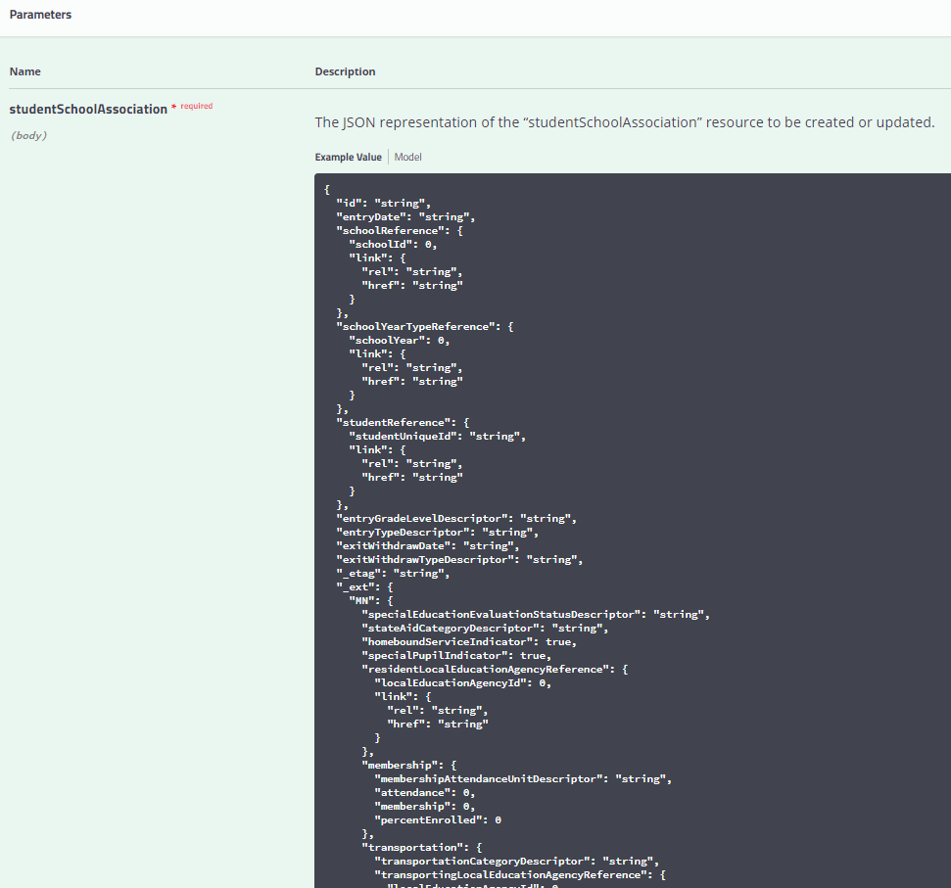

Definitions and Data Types in the **studentSchoolAssociation** can be viewed by selecting **“Model”** just to the right of the "Example Value" option. Required components are marked with a red *. Often, the actual data posting for an individual record can be much less than what is in the model, as demonstrated in [this example record](https://file+.vscode-resource.vscode-webview.net/c:/Users/MDolbow/.vscode/MDE-EdFi-Documentation/data%5Cexample_value_studentSchoolAssociation.json).

## Mapping Documentation

For context around how each MDE collection maps to the Ed-Fi Data Standard, please view the Mapping Matrix documents published by MDE.

Each school year's Data Mapping Matrix spreadsheet includes the mappings between MDE elements and Ed-Fi core and extension entities and elements, in the **Data Elements** tab. Additionally, the Descriptor values applicable to each Collection are also included in these documents for reference, in the remaining tabs of the spreadsheet. (We are currently testing out a process to automate custom descriptor CSVs as exports from the database, allowing you to view individual descriptor tables as well as more easily visualize changes and history.)

## Education Organization Id usage by Resource

Education Organization References in the Ed-Fi API allow an API client to submit either a Local Education Agency, School Id, PostSecondaryInstitutionId; however the MDE implementation **requires** that the following ids must be used for Education Organization References:

| **Resource** | **Element** | **ID** |
| --- | --- | --- |
| StudentEducationOrganizationAssociation | educationOrganizationReference.educationOrganizationId | School Id |
| StudentProgramAssociation (all program types) | educationOrganizationReference. educationOrganizationId | School Id |
| StudentProgramAssociation (all program types) | programReference.educationOrganizationId | State Education Agency Id |
| Course | educationOrganizationReference.educationOrganizationId | District Course –**LocalEducationAgencyId**  State Course (loaded by MDE) – **StateEducationAgencyId**  College Course –**postSecondaryInstitutionId** |
| CourseOffering | SchoolReference  CourseReference | SchoolId  EducationOrganizationId on the Course record |
| ClassPeriod | SchoolReference | SchoolId |
| Section | CourseOfferingReference  ClassPeriodReference | SchoolId  SchoolId |
| studentSectionAssociation | sectionReference.CourseOfferingReference | SchoolId |
| StaffSectionAssociation | sectionReference.CourseOfferingReference | SchoolId |
| Grade | StudentSectionAssociationReference. sectionReference.CourseOfferingReference | SchoolId |
| GradingPeriod | SchoolReference | SchoolId |

## API Resources and Certification Scenarios

Test scenarios are available at the following locations on MDE’s GitHub repository for EdFi:

* [MARSS and Ancestry Ethnic Origin](https://github.com/mn-mde-edfi/MDE-EdFi-Documentation/blob/master/sandbox_cert_b_marss.md)
* [Early Education](https://github.com/mn-mde-edfi/MDE-EdFi-Documentation/blob/master/sandbox_cert_d_earlyed.md)
* [Digital Equity](https://github.com/mn-mde-edfi/MDE-EdFi-Documentation/blob/master/sandbox_cert_f_digital_equity.md)
* [MCCC](https://github.com/mn-mde-edfi/MDE-EdFi-Documentation/blob/master/sandbox_cert_e_mccc.md)
* [21st Century Learning Center Grant Program](https://github.com/mn-mde-edfi/MDE-EdFi-Documentation/blob/master/sandbox_cert_c_spas.md#resource-student21stcenturylearningcentergrantprogramassociation)

## Read-Only API endpoints

Several of the required data elements are provided by MDE within the ODS. This section details those elements.

### Resource: LocalEducationAgencies

#### Description

This entity represents an administrative unit at the local level which exists primarily to operate schools or to contract for educational services. It includes school districts, charter schools, or other local administrative organizations.

#### Prerequisite Data

* None

Note: All required Local Education Agency data will be loaded by MDE

### Resource: Schools

#### Description

This entity represents an educational organization that includes staff and students who participate in classes and educational activity groups.

#### Prerequisite Data

* None

Note: All required School data will be loaded by MDE.

### Resource: Post-Secondary Institutions

#### Description

An organization that provides educational programs for individuals who have completed or otherwise left educational programs in secondary school(s).

#### Prerequisite Data

* None

Note: All required College data will be loaded by MDE.

### Resource: Course (State Level Only)

#### Description

This educational entity represents the organization of subject matter and related learning experiences provided for the instruction of students on a regular or systematic basis.

#### Prerequisite Data

* Education Organization for State Education Agency (SEA)

Note: All required State Course data will be loaded by MDE.

### Resource: Staff

#### Description

This entity represents an individual who performs specified activities for any public or private education institution or agency that provides instructional and/or support services to students or staff at the early childhood level through high school completion. For example, this includes:

1. An "employee" who performs services under the direction of the employing institution or agency is compensated for such services by the employer and is eligible for employee benefits and wage or salary tax withholdings.
2. A "contractor" or "consultant" who performs services for an agreed upon fee or an employee of a management service contracted to work on site.
3. A "volunteer" who performs services on a voluntary and uncompensated basis.
4. An in-kind service provider.
5. An independent contractor or businessperson working at a school site.

#### Prerequisite Data

* none

Note: Sync process will be created by MDE to populate Staff Tables

### Resource: Program

#### Description

Ed-Fi Description: This entity represents any program designed to work in conjunction with, or as a supplement to, the main academic program. Programs may provide instruction, training, services, or benefits through federal, state, or local agencies. Programs may also include organized extracurricular activities for students. MDE will create the following programs with these program types:

* Section 504 Plan
* Title I Part A
* English Learner
* Gifted and Talented
* Special Education
* 21st Century Learning Center Grant
* Alternative Delivery Of SIS
* Coordinated Early Intervening Services
* Homeless
* PSEO Concurrent
* PSEO Program
* School Food Service
* Early Childhood Screening
* SAAP
* School Readiness
* Early Childhood Family Education

## Ed-Fi Model Dependency Graphs

### MARSS collection

Descriptors

Calendar

Schools and LEAs

Student Records

Programs

StudentSchoolAssociation

(Enrollment Records)

Student Program Associations

StudentEducationOrganizationAssociation (Demographic Records)

The above image describes the dependencies required to work with the MDE Ed-Fi model as part of MARSS collections. In detail:

1. Descriptors must be loaded first, as all other resources contain references to descriptor values.
2. Once descriptors are loaded, Education Organization data must be loaded by MDE.
3. Though MARSS is centered around student demographics and enrollment, the core Student records must be loaded before students may be enrolled.
4. Student enrollment data must be provided via StudentSchoolAssociation in order to establish a valid security claim before any other updates may be made to student records.
5. Once student enrollment data is loaded, student demographics may be provided via StudentEducationOrganizationAssociation.
6. Programs must be loaded for all districts submitting data to the ODS.
7. StudentProgramAssociations can be loaded once Programs and StudentSchoolAssociations have been loaded.

### MCCC collection

Descriptors

Calendar

Education Organizations (Schools, LEAs, Colleges, SEA)

Student Records

ClassPeriod

Courses

Course Offerings

Staff

Sections

Grade

Grading Period

Staff Section Association

Student Section Association

The above image describes the dependencies required to work with the MDE Ed-Fi model as part of the MCCC collection. In detail:

1. Descriptors must be loaded first, as all other resources contain references to descriptor values.
2. Once descriptors are loaded, Education Organization data must be loaded by MDE. For the MCCC data collection, Colleges will be loaded to the PostSecondaryInstitution resource to allow the association of a college to a college level course. State courses are associated with the StateEducationAgency.
3. The core Student records must be loaded before students may be enrolled in courses.
4. Student enrollment data must be provided via StudentSchoolAssociation in order to establish a valid security claim before any other updates may be made to student records
5. Courses, course offerings, and sections can be loaded after Education Organizations. State Courses are pre-loaded by MDE.
6. Class Periods can be loaded after Education Organizations.
7. Staff, Staff Section Associations, and StudentSectionAssociations can be loaded after Sections.
8. Once student section enrollment data is loaded, grades and grading period associations can be assigned.

### Early Education Enrollment and Parent collection

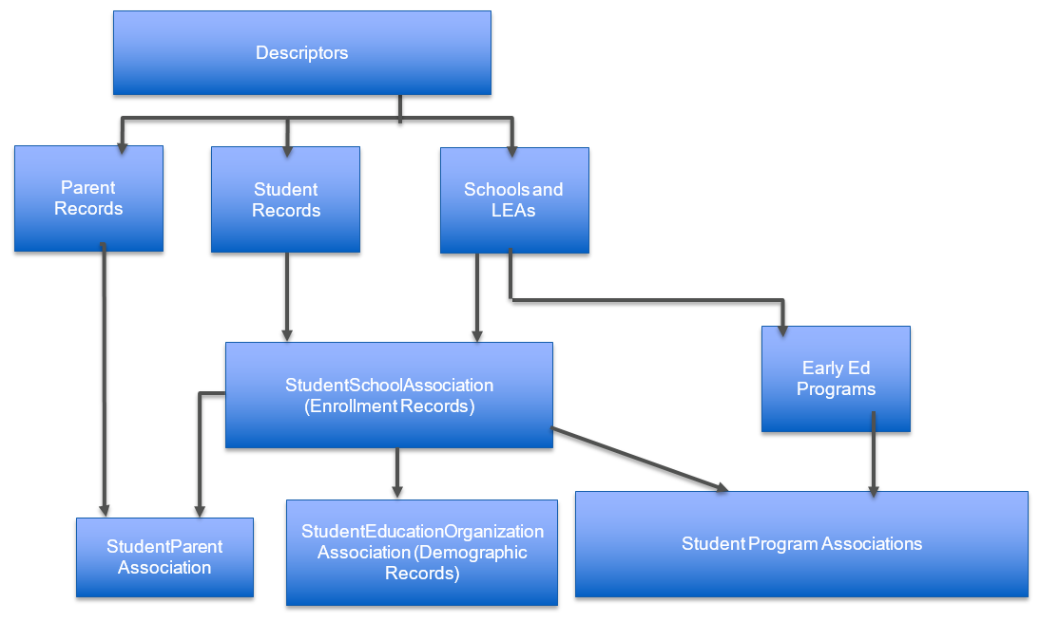

The above image describes the dependencies required to work with the MDE Ed-Fi model as part of Early Education Enrollment and Parent collection. In detail:

1. Descriptors must be loaded first, as all other resources contain references to descriptor values.
2. Once descriptors are loaded, Education Organization data must be loaded by MDE.
3. The core Student records must be loaded before students may be enrolled.
4. Student enrollment data must be provided via StudentSchoolAssociation in order to establish a valid security claim before any other updates may be made to student records. (See more details below.)
5. Once student enrollment data is loaded, student demographics may be provided via StudentEducationOrganizationAssociation.
6. Early Education Programs must be loaded for all districts submitting data to the ODS.
7. StudentProgramAssociations can be loaded once Programs and StudentSchoolAssociations have been loaded.
8. Parent Records, Students and Enrollment records are required prior to setting the Student Parent Association.

#### Grade / Enrollment Requirements for Early Education Enrollment

As described above, each student must first have a StudentSchoolAssociation record (an enrollment record). For EE Enrollment, allowable grades are EC, K-3 or EE.

* Use Grade EE if the student is not already enrolled in a regular grade
* Use Grade EE if the EE program service is provided in a different school than the regular grade.

Once the enrollment record exists, one or both of the EE Program Associations may then be assigned to the student.

* Students in Grade EC, K-3 may only have an EE-ECFE program assigned; they cannot have an EE-SR program assignment.
* Only Grade EE students may have an EE-SR program.
* Grade EE students may also have an EE-ECFE program alone or in combination with an EE-SR program.

# Staging Environment Load and Quality Check

At the completion of Scenario based testing in the Sandbox environment, MNIT will grant vendors a key and secret for the district they are working with in the staging environment. In the staging environment, vendors will load actual student data, with student enrollment (studentSchoolAssociation), demographic (studentEducationOrganizationAssociation), program and calendar information.

The base Staging Environment URL is: **https://stage.edfi5.education.mn.gov/api/**

## Ed-Fi / MARSS Identities API Integration Test

Vendors have the option of building in support for interfacing with the MN Student Identity System to create new MARSS Student IDs (Ed-FI Unique Id) through an Ed-Fi Identities API implementation. Vendors will be able to test their State ID creation integrations in the Staging environment.

Vendors must demonstrate their ability to create new Student IDs when a Student is created in the Student Information System.

This would be accomplished by posting to the /identities endpoint.

The URL for the identities API in the Staging environment is: Not currently active

The general process for identity creation is as follows:

* A Vendor posts a new Student Identity including the following properties to the ODS/API identities end-point:

{

"stateStudentId": "000010000000",

"educationOrganizationId: "255901",

"lastSurname": "LastSurname",

"firstName": "FirstName",

"middleName": "MiddleName",

"generationCodeSuffix": "Suffix",

"birthDate": "2005-12-15T00:00:00",

"sexType": "Male"

}

* The identities API validates the student information against the MN Student Identity System.
* If no match is found in the Student Id System – the student id is created
* An HTTP response code 201 created is returned from the ODS/API.
* If the Student ID System returns an error the student id will fail to be created and an HTTP status code 400 Bad Request with the corresponding message for the error given is returned from the ODS/API (see specific errors below under Test 2)

### Create Student ID Test 1

Description: Vendor posts a new Student Identity to the ODS/API identities end-point.

Vendor submits Id with additional identifying attributes, and ID is created successfully

**Sample JSON**

{

"stateStudentId": "000010000000",

"educationOrganizationId: "255901",

"lastSurname": "LastSurname",

"firstName": "FirstName",

"middleName": "MiddleName",

"generationCodeSuffix": "Suffix",

"birthDate": "2005-12-15T00:00:00",

"sexType": "Male"

}

**Response**

201: created

### Create Student ID Test 2

Description: Vendor posts a new Ed-Fi Student record to the Identities endpoint for the following error conditions:

| **Error** | **Description** | **Details** |
| --- | --- | --- |
| 3000 | (Input SSID not equal SSID) | Student identifying information given matches a single student, but the State Student Id specified as input does not match the official State Student Id of the matched student. |
| 3001 | (Multiple SSIDs found) | Student identifying information given matches multiple existing students. |
| 3003 | (Possible Student Already Exists) | Student identifying information given does not match any students. However suspect student matches found using Clean Last Name Initial, Clean First Name Initial, Birth Date and gender equal. Review needed. |
| 3004 | (Possible Student Already Exists) | Student identifying information given does not match any students. However suspect student matches found using Clean Last Name, Clean First Name equal. Exact match. Review needed. |
| 3005 | (Possible Student Already Exists) | Student identifying information given does not match any students. However suspect student matches found using Soundex of Clean Last Name, Soundex of Clean First Name, Gender, and Birth Date + or - 1 year. Review needed. |
| 3006 | (Possible Student Already Exists) | Student identifying information given does not match any students. However, the State Student Id is already in use by a non-matched student. Review needed. |

**Response**

400: BAD REQUEST { “message”: “<error number> <error description><error details>” }

Vendors will be expected to demonstrate a mechanism for timely reporting of ID creation errors back to users, either through the SIS user interface, or through a separate interface, or reporting method.

## Ed-Fi / MARSS Student Record Validation Test

When Student Records are created or updated in the Ed-Fi ODS, the API will perform a look up against the MN State Student ID System to determine whether the student is associated to a valid student id.

This validation feature will be enabled in the Staging Environment. Vendors must capture validation errors returned in the API response and surface these errors to district users.

### Student Validation Process Overview

* SIS posts a new or updated Student record to the Ed-Fi API.
* The Ed-Fi student validator then calls the MDE Student ID System validation process with StateStudentId (StudentUniqueId), LastName, FirstName, BirthDate, and BirthSex.
  + If the MDE Student ID System returns 0 (Exact Match), the student identity matches all the information exactly and only a single student is found. The Ed-Fi API will allow the Student record to be stored in the ODS. The Ed-Fi API returns HTTP response code 204.
  + Any other return value from the MDE Student ID system validation process results in HTTP response code 400 Bad Request, which also passes back the error code and message from the MDE Student ID System. The SIS should present this error code and message to the district user, informing them of the Student ID issue which must be resolved in the MDE Student ID system.

### Validate Student ID Test 1

Description: Vendor posts a new valid Ed-Fi Student record to the ODS/API Student end-point.

Vendor submits Ed-Fi student record to the student’s resource endpoint using a valid student id and associated to the same student.

**Response**

201: created

### Validate Student ID Test 2

Description: Vendor posts a new Ed-Fi Student record to the ODS/API Student end-point for the following error conditions:

| **Error** | **Description** | **Details** |
| --- | --- | --- |
| 3000 | (Input SSID not equal SSID) | Student identifying information given matches a single student, but the State Student Id specified as input does not match the official State Student Id of the matched student. |
| 3001 | (Multiple SSIDs found) | Student identifying information given matches multiple existing students. |
| 3002 | (No match found0 | Student identifying information given does not match any students. Also no possible suspect student matches found. (May be safe to add as a new student.) |
| 3003 | (Possible Student Already Exists) | Student identifying information given does not match any students. However suspect student matches found using Clean Last Name Initial, Clean First Name Initial, Birth Date and gender equal. Review needed. |
| 3004 | (Possible Student Already Exists) | Student identifying information given does not match any students. However suspect student matches found using Clean Last Name, Clean First Name equal. Exact match. Review needed. |
| 3005 | (Possible Student Already Exists) | Student identifying information given does not match any students. However suspect student matches found using Soundex of Clean Last Name, Soundex of Clean First Name, Gender, and Birth Date + or - 1 year. Review needed. |
| 3006 | (Possible Student Already Exists) | Student identifying information given does not match any students. However, the State Student Id is already in use by a non-matched student. Review needed. |

**Response**

* The Ed-Fi Student record is unable to post.
* An HTTP status code 400 Bad Request and the corresponding message for the error given is returned from the ODS/API.
* Vendor Captures error and displays for district user.